- A hydrocarbon is a gas at room temperature. When 1 mole of the compound burns in air, 2 mole of CO₂ are produced. When it is bubbled into bromine water, the bromine loses colour. Which of the following compounds could it be?

- C₂H₅OH b) CH₂CHCH₃

- CH₃CH₃ d) CH₂CH₂

- Asprin, whose structure is shown, contains which functional groups?
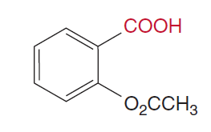
- A ketone and an alcohol
- An ester and a ketone
- An ester and a carboxylic acid
- A ketone, alcohol and ester

- From the list of 4 compounds below, identify the compound that is NOT an isomer of any other compound in the list.

Butuanoic acid, butanal, methylpropanoate, ethylethanoate

- Butuanoic acid
- Butanal
- Methylpropanoate
- Ethylethanoate

- Which of the following pure substances will have the highest melting point?

- Ethane
- Ethanal
- Ethanoic acid
- Ethanol

- Which of the following compounds can have geometric isomers?

- CH₃ CH₃ b) CH₃ H
| |
C = C H – C – C – H
| |
CH₃ CH₃ H CH₃

- CH₃ CH₃ d) CH₃ Br

C = C C = C

H CH₃ H CH₃

- A student labelled an organic compound 1-bromo-2,2-dimethylethane, but the name was incorrect according to IUPAC standards. The correct name would be

- 2-dimethyl – 1 – bromoethane
- 1-bromo-2-methylpropane
- 2-methyl-3-bromopropane
- 1,1-dimethyl-2-bromoethane

- Which of the following substances would you expect to be most soluble in water?

- 1-butanol
- Pentane
- Propanone
- Methylpropanal

- Which of the following statements is FALSE?

- Oxidation of 1-butanol with potassium permanganate produces butanal and subsequently butanoic acid
- Oxidation of 2-butanol with potassium permanganate produces 2-butanone
- Methane when treated with hydrogen chloride produces chloromethane and hydrogen gas
- Ethanoic acid reacts with magnesium to produce hydrogen gas.

Study the section of polymer below to answer questions 9 and 10:

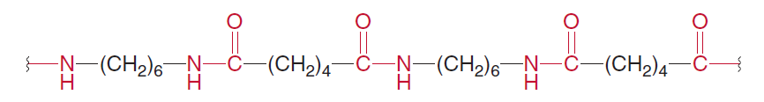

- This segment is probably part of

- A polyester
- A polyamine
- A polypeptide
- A polycarbide

- A monomer from the polymer could be:

NH₂ – CH₂ – CH₂ - COOH
- b)

c) d)

COOH – (CH₂)₆ – COOH

COOH – (CH₂)₅ – NH₂

NH₂ – (CH₂)₆ –NH₂

END OF MULTIPLE CHOICE



Year 12 Chemistry
Organic Chemistry Test 2016

Student Name: kk
Teacher: kk

- 60 minutes working time
- Non-programmable calculator and data sheet allowed.

Multiple Choice | Short Answer | Extended Answer | Total
10 | 23 | 27 | 60

Section I – Multiple Choice

Mark your choice with a cross (X). Please do not circle your answer.

- A B C D
- A B C D
- A B C D
- A B C D
- A B C D
- A B C D
- A B C D
- A B C D
- A B C D
- A B C D

Section II – Short Answer Questions

Question 1
Identify the organic reactants that could be used to produce each of the following organic compounds (name or chemical formula):
Compound | Reactants
Butanone
2-bromopropane
Ethylheptanoate

[3 marks]
Question 2
Give the correct IUPAC name or complete structural formula for the following compounds:
IUPAC Name | Structural Formula
2-amino-3-hydroxy-pentanoic acid
CH₂ - CH – CH₂ – CHO
| |
F Br

CH₂ = CH – CH – CH₂ – CH₃
|
CH₂ – CH – CH₃
|
CH₃
2,4-dimethyl-cyclohexanol

[4 marks]
Question 3
Write balanced equations for the following reactions:
a) Combustion of octene in a plentiful supply of air.

[2 marks]
b) The reaction between ethanoic acid and solid sodium carbonate.

[2 marks]
c) The reaction between potassium dichromate with ethanal.

[3 marks]

Question 4
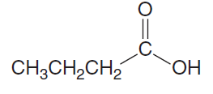
The molecular formula C₄H₈O₂ can represent the molecule shown below:

Butanoic acid:

There are many isomers of this molecule. Draw two that are esters and one that is a carboxylic acid.

Structure
Ester

Ester

Carboxylic acid

[3 marks]

Question 5
- What is a monomer?

[1 mark]
- Poly vinyl acetate is a soluble polymer with the following structure.
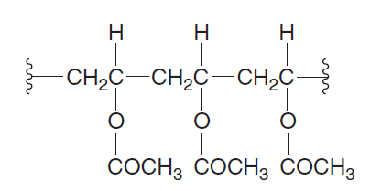

- Draw the structure of the monomer responsible for the polymer.

[2 marks]

- The structural formulae for terephthalic acid and 1,3-propandiol are shown below:

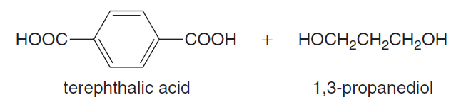

Using these monomers draw a section polymer showing exactly two complete repeating units.

[2 marks]
- State the type of polymerization involved in this reaction:

[1 mark]

Section III – Extended Answer Questions

Question 6
Amino acids form polymers through peptide linkages.

- Connect two alanine molecules with a peptide link.

[2 marks]

- Amino acids exist as zwitterions. Rewrite alanine as it would be found at the pH values indicated below:

pH | Structure of Alanine
3
7
10

[3 marks]

- Circle and name the three amino acids that have been used to make the polypeptide shown below.

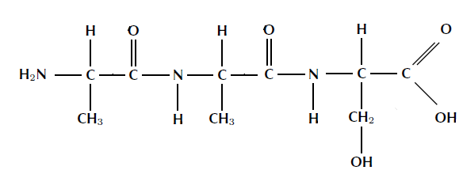

[3 marks]
- Explain the following with regard to protein structure and explain how each structure is held together.

Primary
Secondary
Tertiary

[3 marks]

- Label the different parts of the diagrams below:

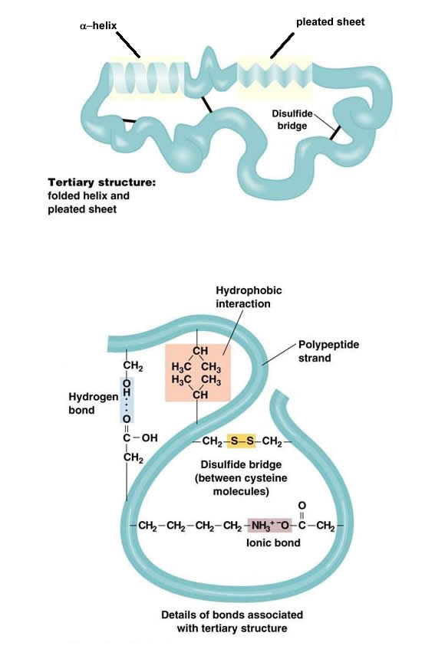

_________________structure

Details of bond types

[7 marks]
- Explain how heat and pH changes can disrupt protein structure.

[3 marks]
Question 7
A sample of a compound containing carbon, hydrogen and nitrogen only was burned in oxygen and produced 2.64 g of carbon dioxide, 0.630 g of water and 0.460 g of nitrogen dioxide.
- Calculate the empirical formula of the compound.

[5 marks]
- If the molecular mass of the compound is approximately 93 g.mol⁻¹, determine the molecular formula of the compound.

[1 mark]

